**Showing the two text files are in cloudera/workspace/HadoopData**

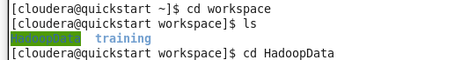

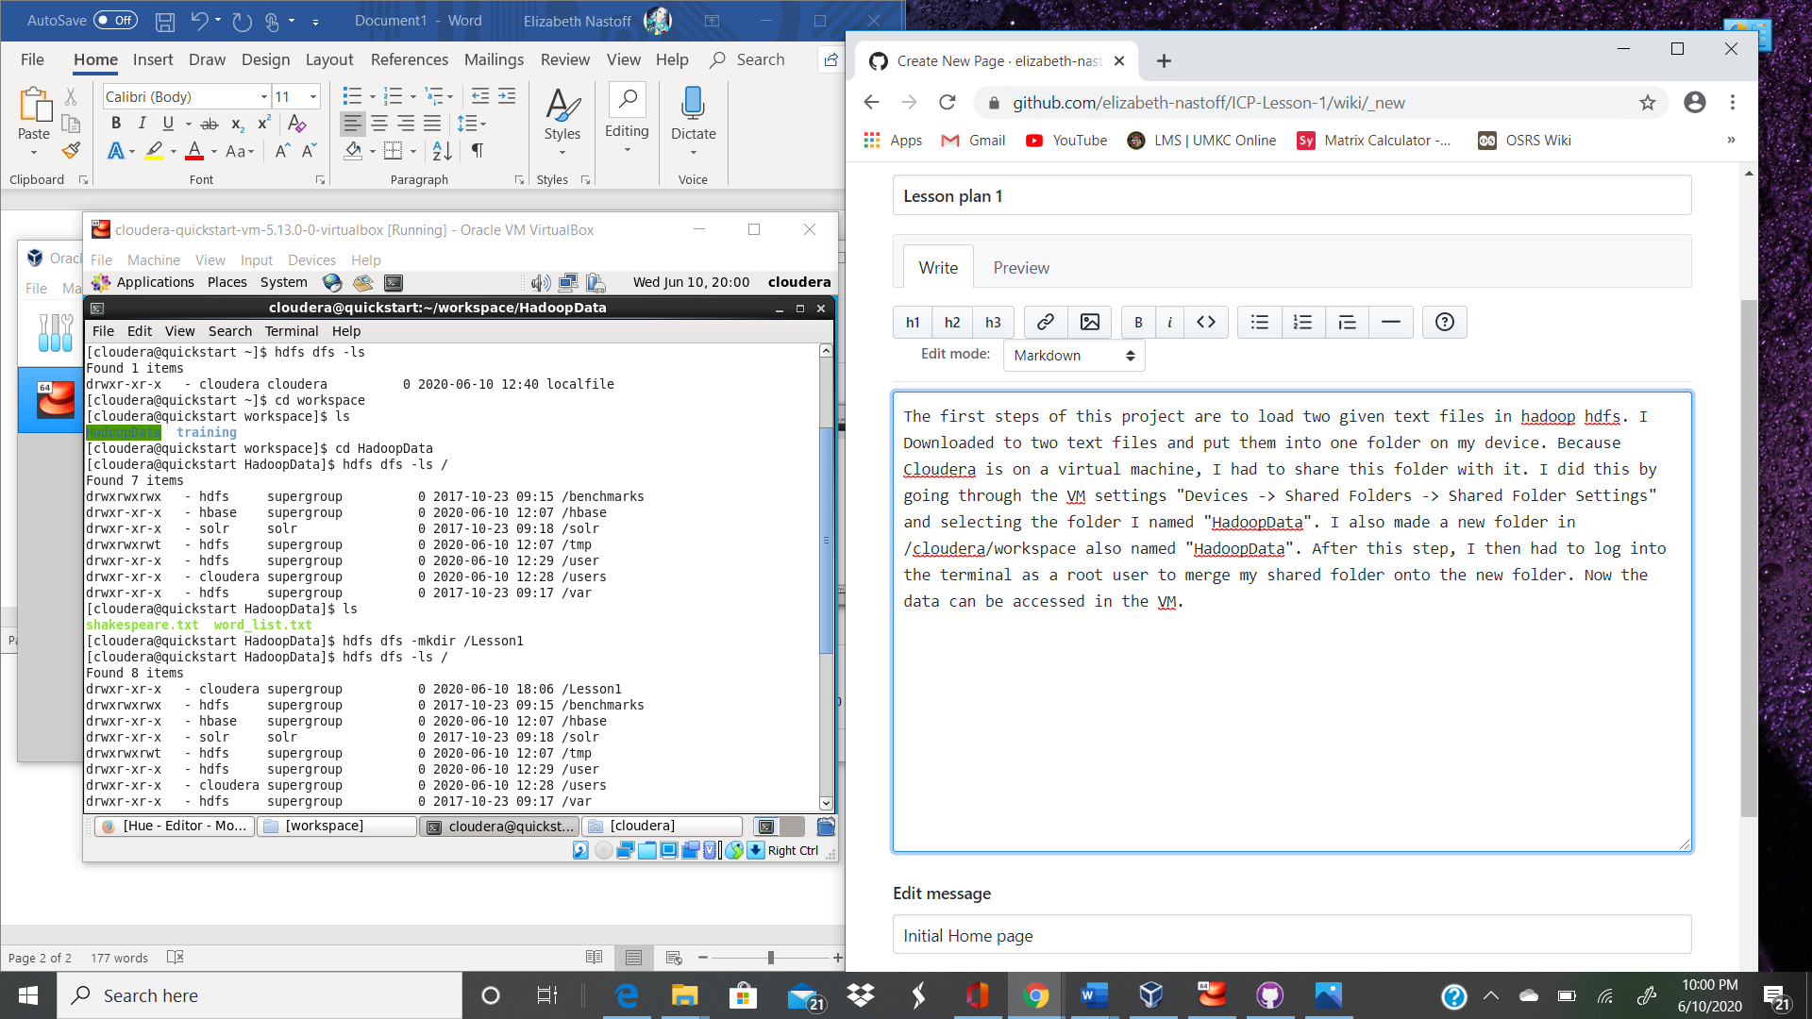

**New directory made**

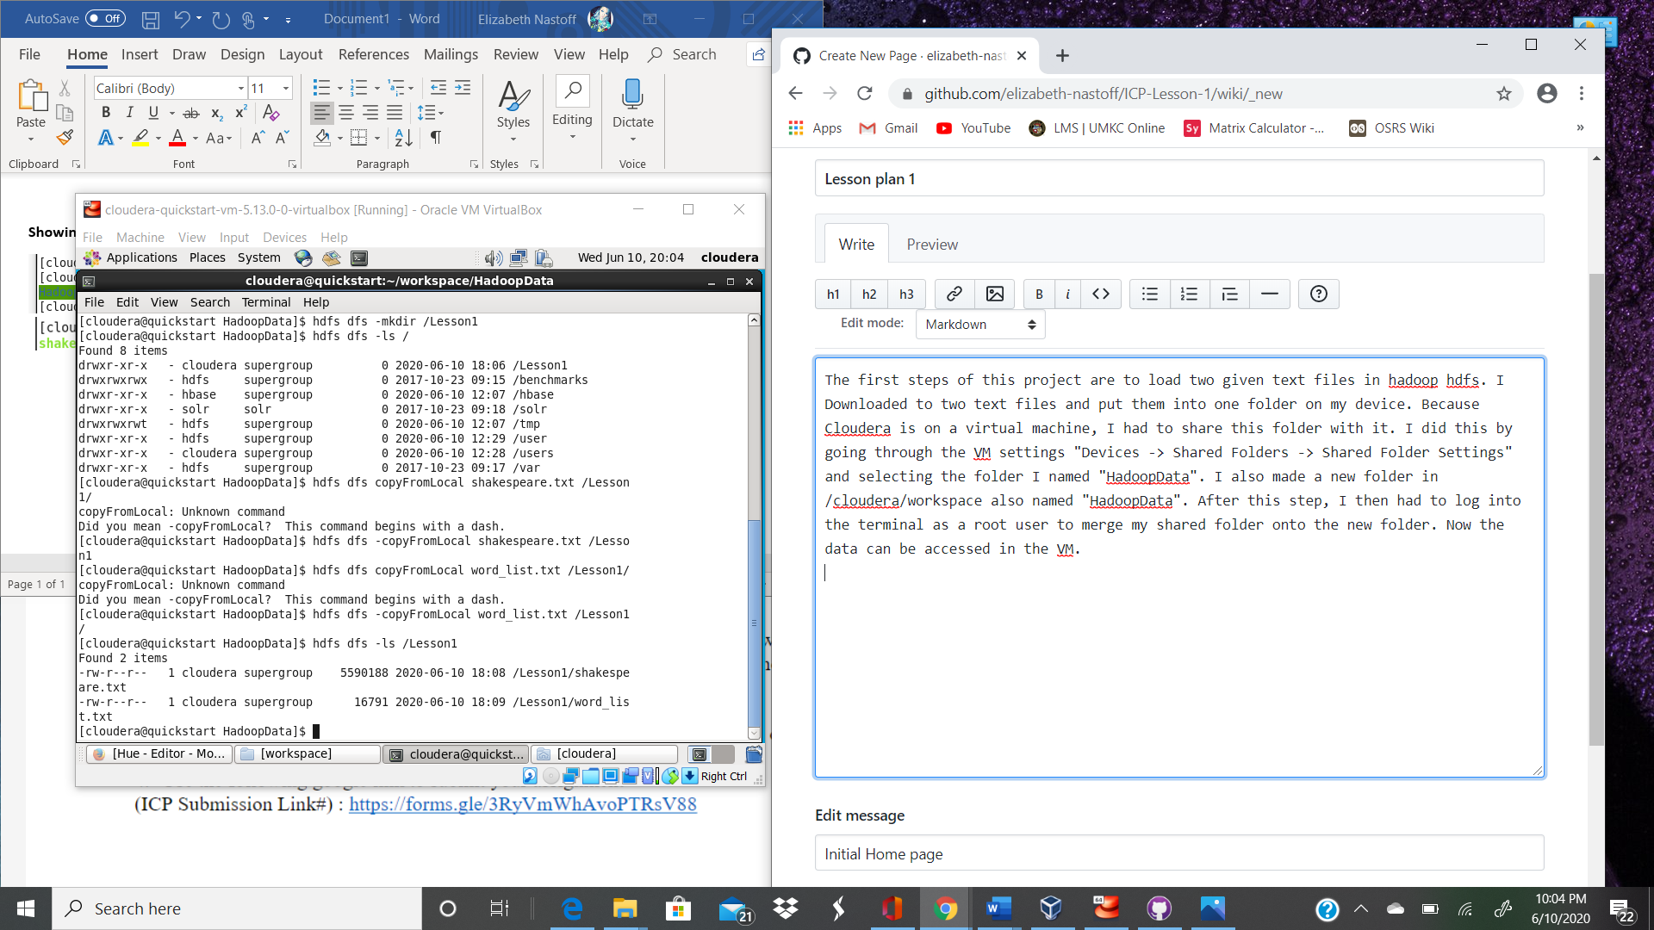

**Text Files are now in the new directory.**

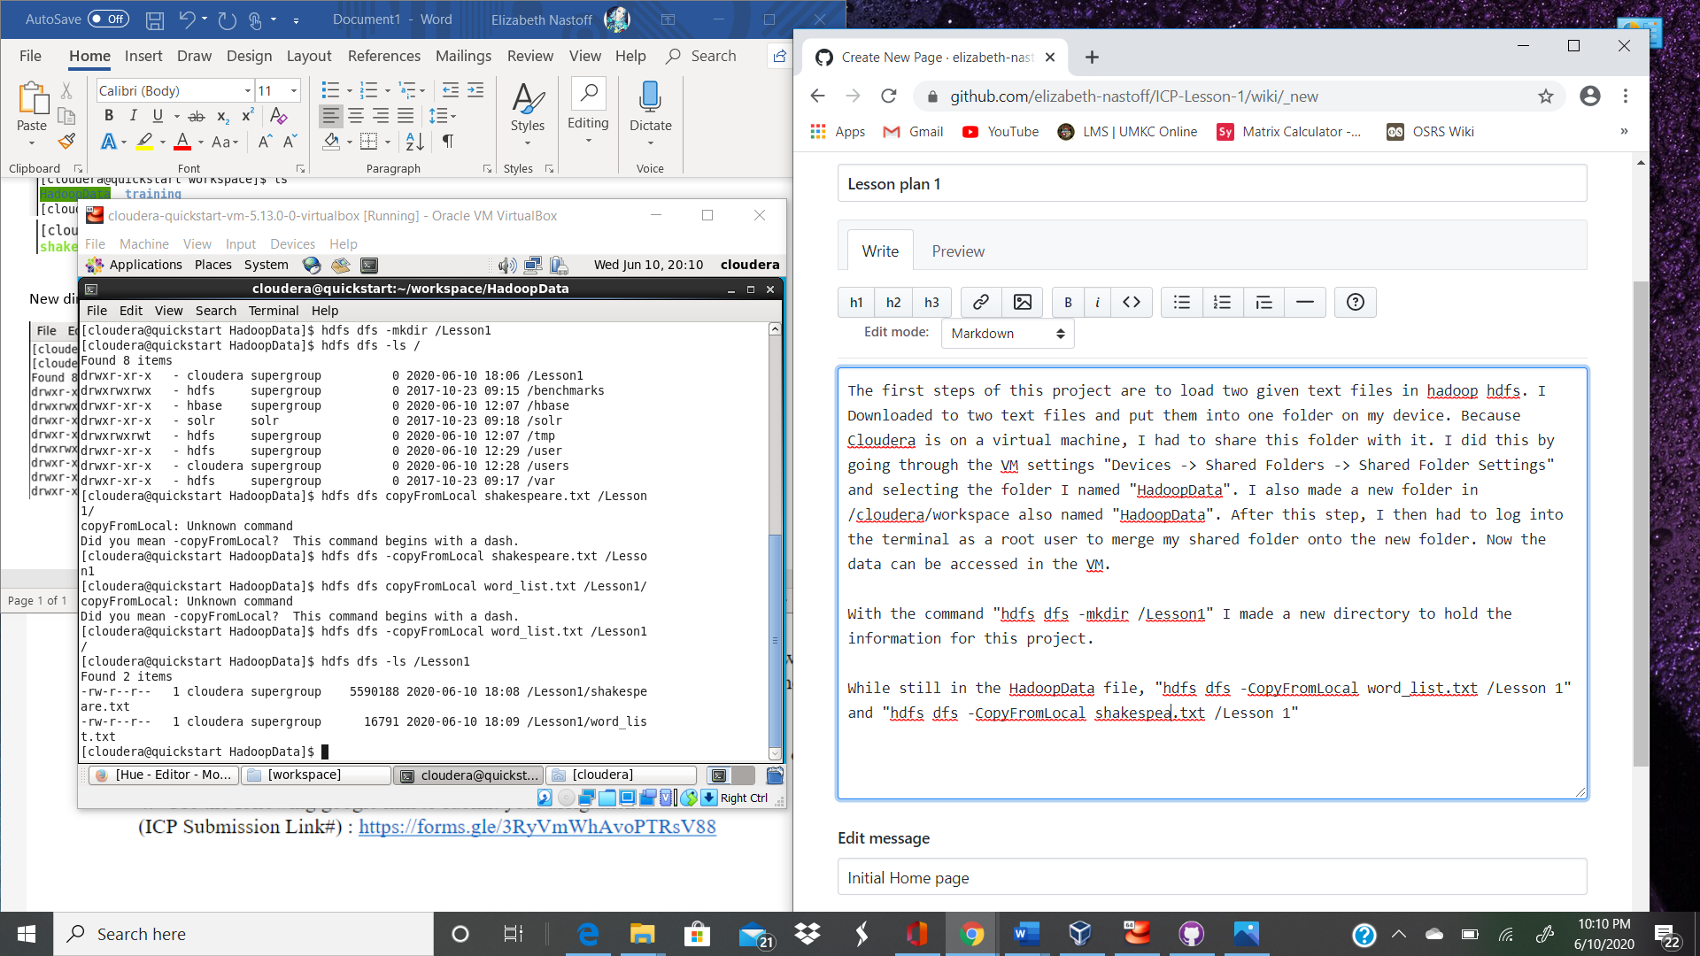

**Appending “words_list” to the end of “shakespeare”.** Screenshot also includes my typo that threw an exception but still made a new file called “shakespear.txt” consisting only of all the content in “words_list”

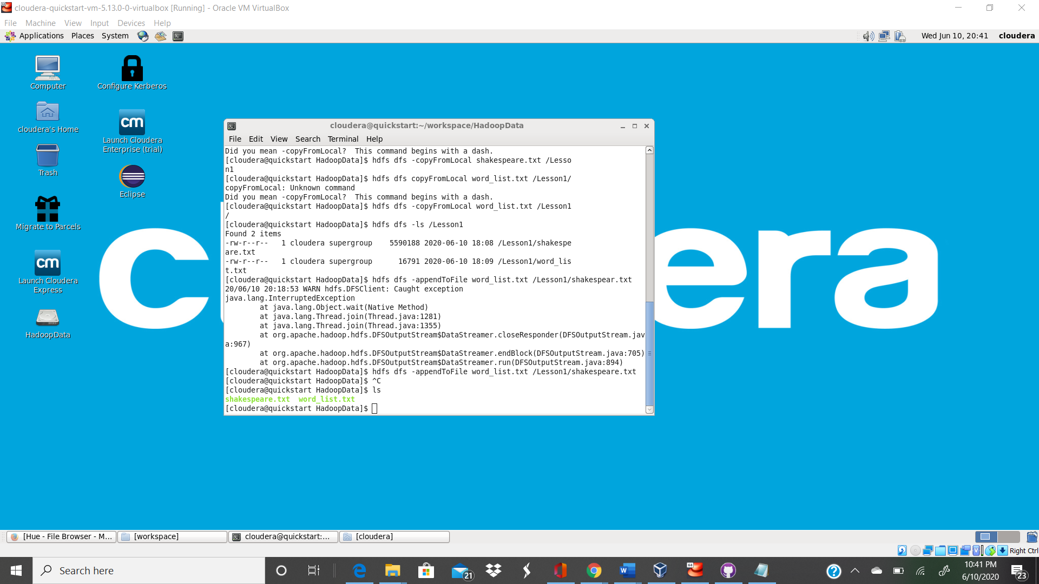

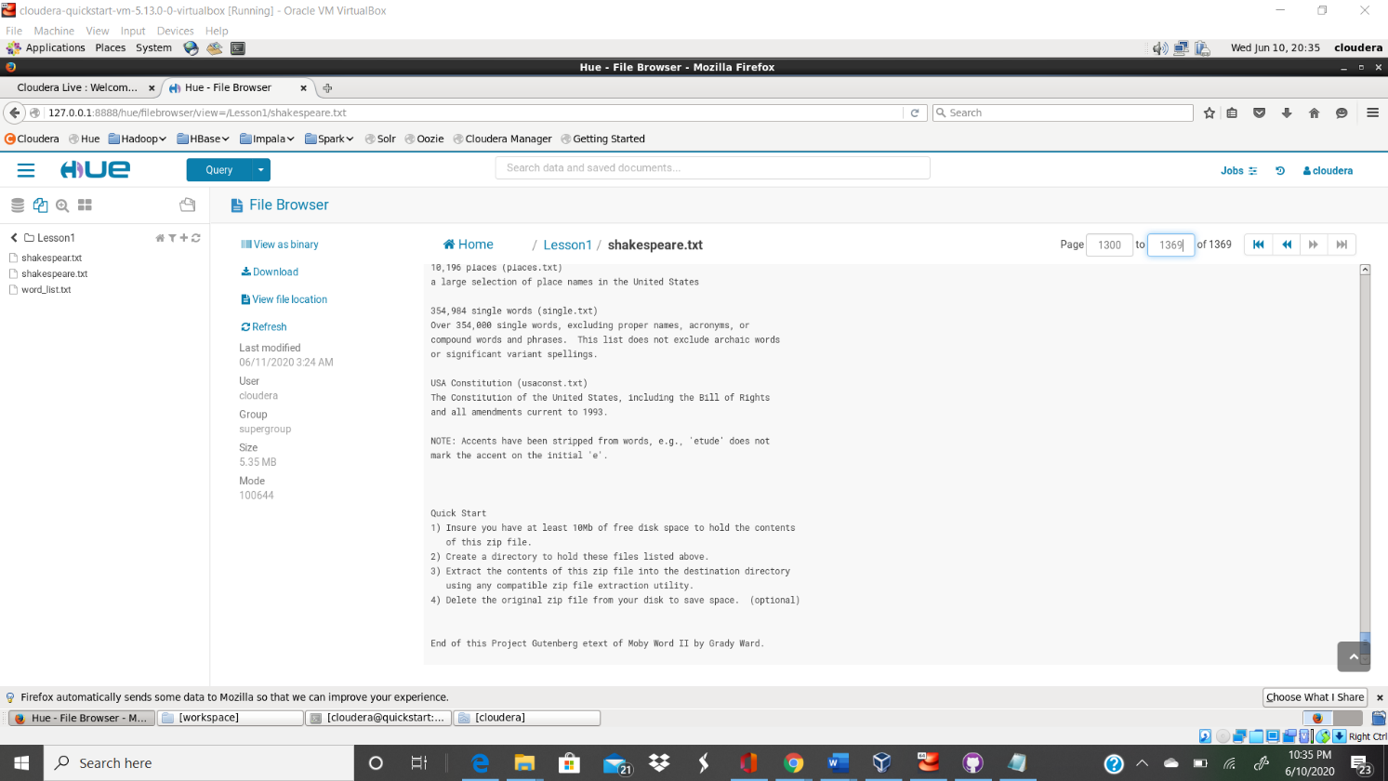**Viewing the updated text file in Hue.** You can tell the two files were merged because of the page count. This is viewing the very end of the Shakespeare file which now includes words_list.

**First I misspelled Shakespeare, notice it created a new file

**Views the first and last 5 lines of the merged dataset with the hdfs cat command**

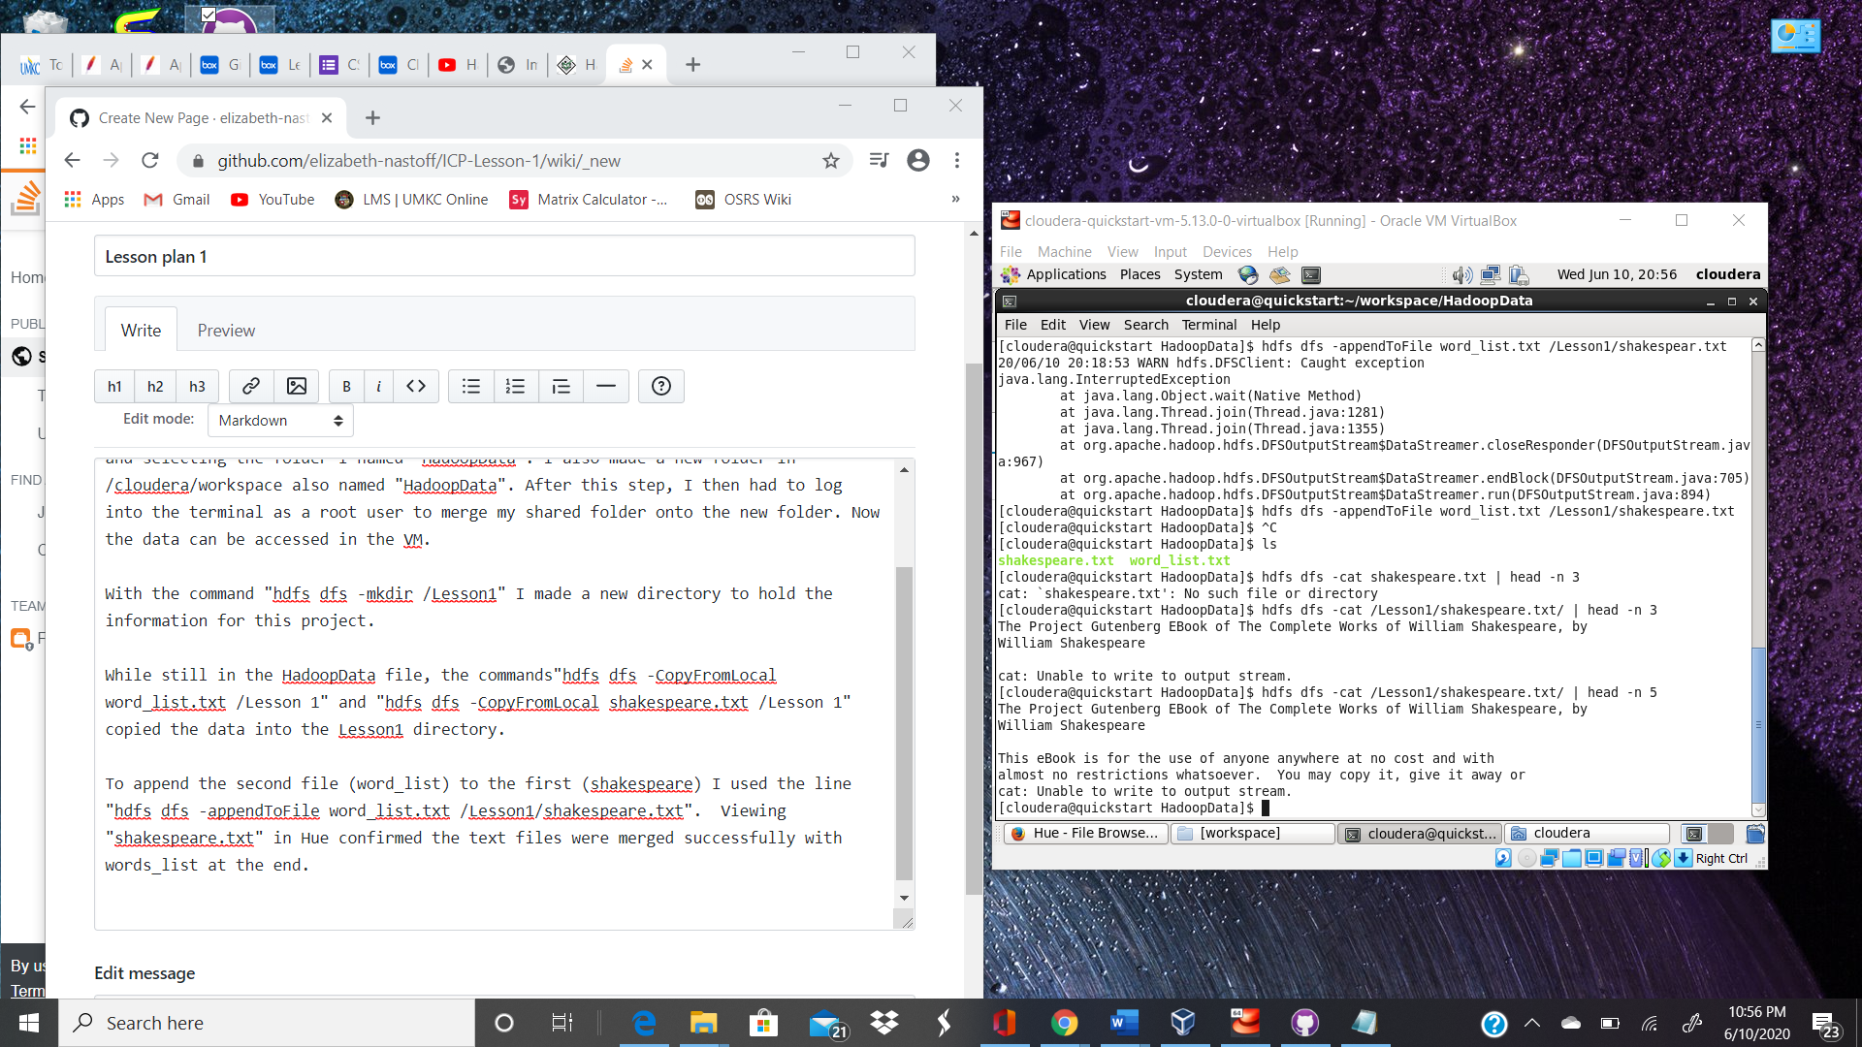

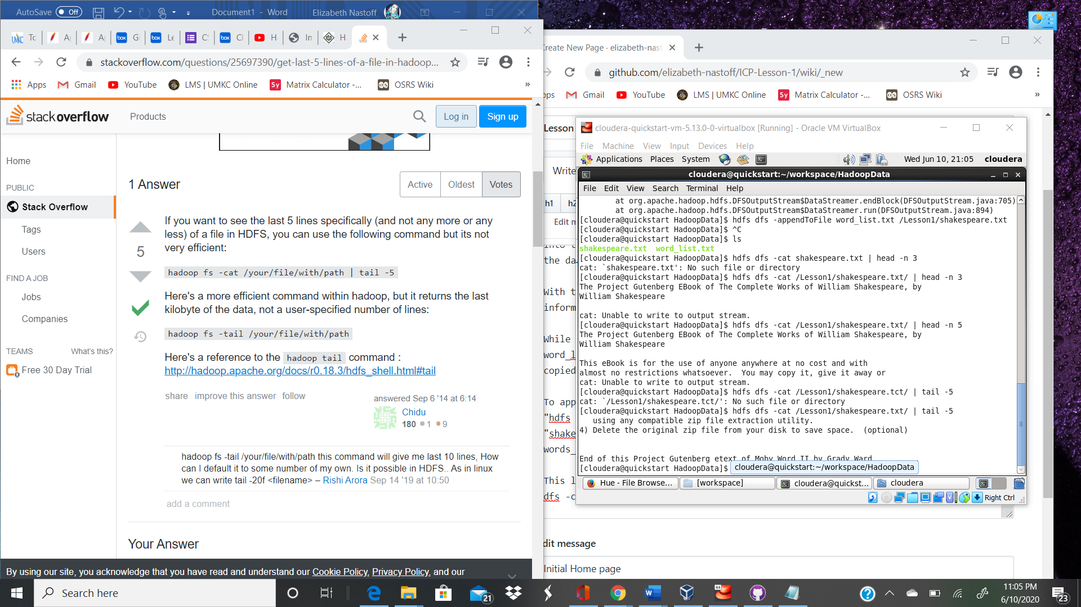

**Create a new text file, load it into hdfs, and append all three files**

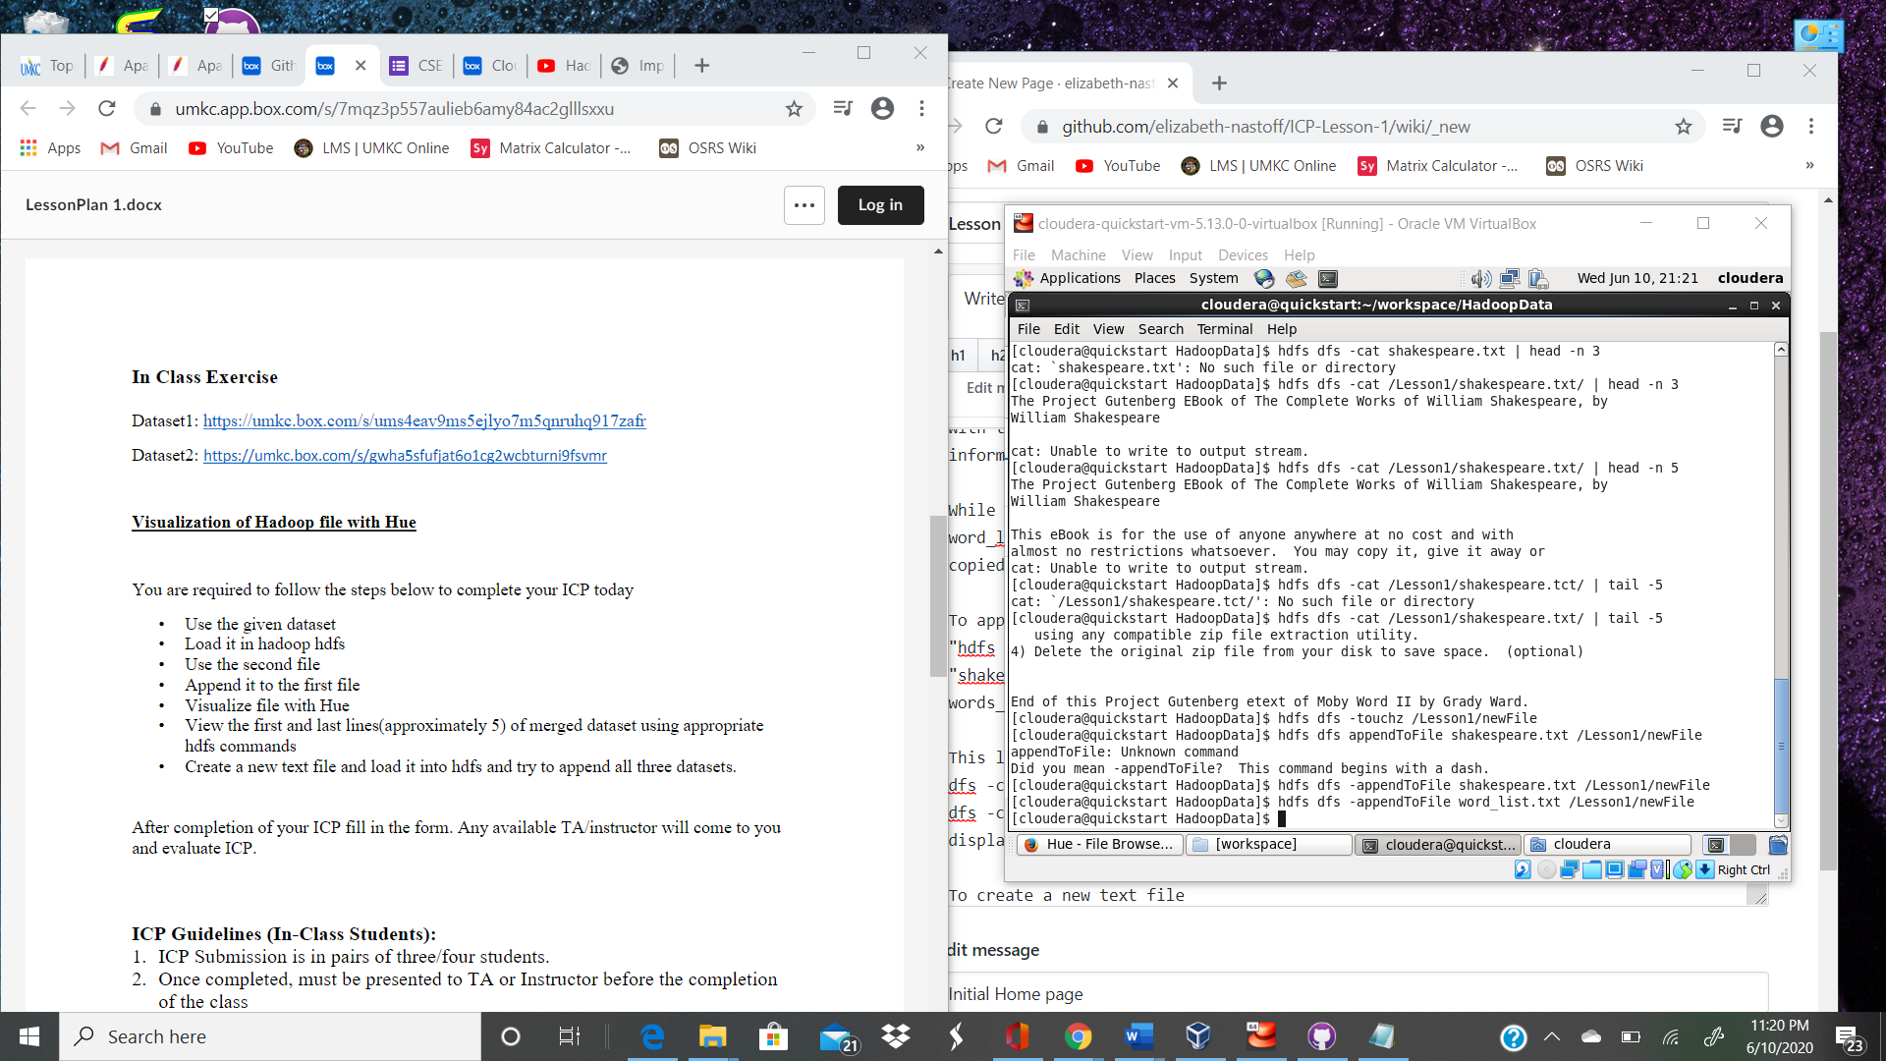

**ignore error of not placing the “-“ in “-appendToFile”

Here is the new file viewed in Hue.

